Pinnacle high international school
Date: 21th August, 2019

Dear Parent / Student
This is to inform you that the school has arranged a Camp to Silvassa for the students of Standards 4 to 6 for 03 days as per attached itinerary between the date 20/9, 2019 to 22/9, 2019.

Mentioned below are the details of the trip:

VENUE : Silvassa

ACCOMMODATION : In decent star category hotels with deluxe rooms on quadruple/multiple
sharing basis with attached bath & all modern amenities..

TRANSPORTATION : By semi – luxury AC deluxe coaches.

MEALS : Delicious Veg / Jain buffet meals with snack hampers, cold
drinks & chocolates hampers at regular intervals during journey.

SIGHTSEEING : Toy factory & Tribal museum, Team building games, Deer park, Lion
Safari, Botanical Gardens, Night Games, Treasure hunt, Madhuban Dam Magic Forest Eco Park

TRIP COST : Rs. 7500/- per student

Amount can be paid by Cash or cheque in favor of (Adventure Education Tours (Mumbai) Pvt. Ltd)

Tour Cost Includes : > Transportation Mumbai to Silvassa to Mumbai & In and around by AC
Coaches
> Accommodation in deluxe star category resort on multiple sharing basis
> Buffet choice of Veg / Jain meals
> Branded Snack, chocolate and cold drink hampers
> Branded Packaged Drinking unlimited Mineral Water
> Snacks on all journeys
> Entrance charges, Toll Taxes, Permits
> Fees for professional guides wherever applicable
> Insurance coverage policy of Rs1, 00,000/- for loss of life & accident per student
> Well equipped First Aid kit on trip
> Male/ female representatives from Adventure Education Tours (Mumbai) Pvt. Ltd
> Please note depending on the day itinerary venue can be changed as per open /
close time.

- We will provide the actual itinerary with detailed information like Hotel details, Contact No, Transport Logistics a few day prior to departure as this is just a suggested itinerary and details may change depending on days selected and as per availability of Transport, Logistics & Accommodation.

- Please Note :
Enrolment process: The last date for enrolment for students / teachers _____ any form & payment if paid after the enrolment date will not be valid unless you have a written confirmation from the teachers’ incharge of school who has also taken a confirmation from the company. Failing to do so the company is bound to return the collected amount if the logistics to process the booking is unavailable

THE TOUR IS CONDUCTED BY: Adventure Education Tours (Mumbai) Pvt. Ltd

PRINCIPAL
Detailed Itinerary for Camp to
SILVASSA with Magic Forest Eco Park
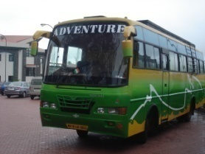

DAY 01:
07.00 am Assemble in school
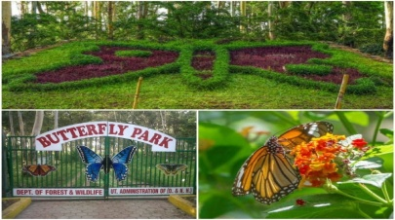
07.30 am Leave from School
08.30 am Breakfast will be served en route
11.30 am Reach resort & allotment of room
11.45 am Rules & instructions will be given
01.00 pm Lunch will be served
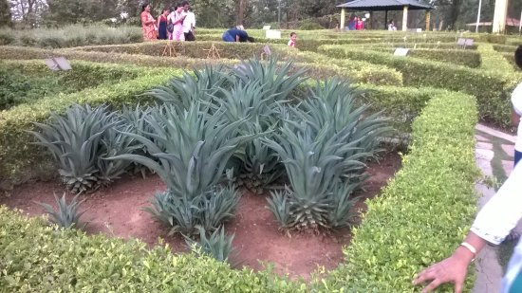
01.30 pm Rest
03.30 pm Leave for Sightseeing
Madhuban Dam
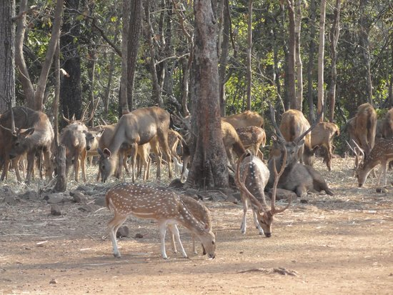
Botanical Park & Butterfly Park
07.30 pm Night Games
08.30 pm Dinner
09.30 pm Entertainment
10.30 pm Lights out

DAY 02:
07.00 am Rise
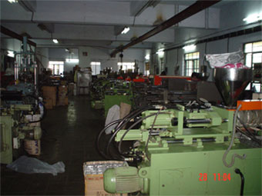
07.30 am Hike
08.30 am Breakfast
09.30 am Leave for visit to Factory
Thereafter visit to Tribal Museum
01.30 pm Back to hotel for lunch
02.30 pm Leave for Lion Safari
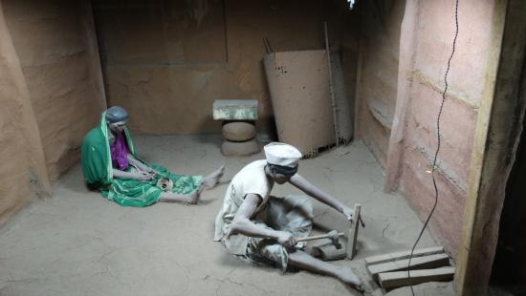
Thereafter visit to Deer Park
05.30 pm Back to hotel and freshen up
06.30 pm Time to prepare for campfire
07.30 pm Enjoy night games
08.30 pm Dinner
09.30 pm Campfire
10.30 pm Lights out
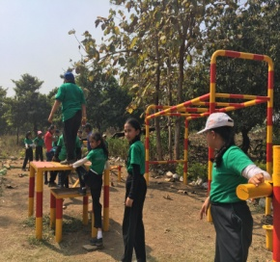
DAY 03:
07.00 am Rise
07.30 am Hike
08.30 am Breakfast
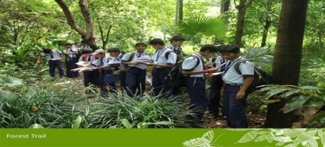
09.30 am Pack up and leave for Magic Forest Eco Park
11.00 am Reach and enjoy the following activities
> Adventure Activities > Natur e Trail
> Dynamic Challenge Course
> Gaushala Visit
> Hands on experience with Warli Painting
01.00 pm Have lunch & then continue with activities
03.30 pm Leave for school
06.00 pm Reach school & depart home with sweet memories

Please Note: We will provide the actual itinerary with detailed information like Hotel details, Contact No, Transport Logistics a few days prior to departure as this is just a suggested itinerary and details may change depending on days selected and as per availability of Transport, Logistics & Accommodation.
Pinnacle high international school
EDUCATIONAL TOUR ENROLLMENT FORM

Form No: ______

NAME__________________________________________________________________________________

STD_____ DIV______ ROLL ______ AGE ______ Date of Birth_________

MEALS: Veg ___ Jain _____ Gender: Male _____ Female _____

ADDRESS________________________________________________________________________________

_________________________________________________________________________________________

Tel No: Resi: _____________________Office__________________________Mobile___________________________

Email ID: ____________________________________ Parent Email ID: ___________________________________

Any other useful information: _______________________________________________________

Cancellation Charges:
120 days prior to departure cancellation : 20% of the trip cost will be deducted as cancellation charges
90 days prior to departure cancellation : 40% of the trip cost will be deducted as cancellation charges
60 days prior to departure cancellation : 60% of the trip cost will be deducted as cancellation charges
15 days prior to departure cancellation : 80% of the trip cost will be deducted as cancellation charges
07 days prior to departure cancellation : 90% of the trip cost will be deducted as cancellation charges
03 days prior to departure cancellation : 100% of the trip cost will be deducted as cancellation charges

INDEMNITY LETTER
(To be filled by the parent)
To,
The Principal,
Pinnacle high international school,
Mumbai .

Respected Madam,

I shall be pleased to send my son / daughter

Name : ___________________________________________________________________________
for the tour to Silvassa with Magic Forest Eco Park.

I have read the cancellation rules & regulations and payment terms & conditions and are willing to abide by them.

Whilst appreciating your assurance for the safety of my child, I undertake not to hold The School Management, the Principal, the Staff and The Travel Agent responsible or liable for any damages, loss of life, loss of baggage, injury or accidents or change in itinerary programme due to unforeseen circumstances.

I am aware that this is a proposed itinerary and the final itinerary & details will be given at the time of parent’s orientation with all final details of the tour.

Signature of the Parent: ______________________________________ Date: _______________________

Name of parent: _____________________________ {relation} ____________________

